

Department of Electrical and Electronic Engineering

EEE109 Electronic Circuits

Lab 1：Diodes Characteristics and Their Applications Report

Name : Tiankuo.Jiao
Student ID : 1929098
Submission date:09/11/2020

Catalogue

Abstract 4
1.Introduction 4
1.1 The background of diode 4
1.2 The experiment content 4
1.3 The organization of the report 5
2.Experiment procedure 5
2.1 Rectification 5
2.1.1 Experiment equipment 5
2.1.2 Experimental steps 5
2.1.3 Experimental results 5
2.1.4 Brief summary 8
2.2 Smoothed rectifier 8
2.2.1 Experiment equipment 8
2.2.2 Experimental steps 8
2.2.3 Experimental results 9
2.2.4 Brief summary 11
2.3 Limiter/Clipper 12
2.3.1 Experiment equipment 12
2.3.2 Experimental steps 12
2.3.3 Experimental results 13
2.3.4 Brief summary 16
2.4 Voltage Clamper 16
2.4.1 Experiment equipment 16
2.4.2 Experimental steps 17
2.4.3 Experimental results 17
2.4.4 Brief summary 20
2.5 Diode logic 20
2.5.1 Experiment equipment 20
2.5.2 Experimental steps 21
2.5.3 Experimental results 21
2.5.4 Brief summary 22
2.6 Zener Stabiliser 22
2.6.1 Experiment equipment 22
2.6.2 Experimental steps 22
2.6.3 Experimental results 23
2.6.4 Brief summary 25
2.7 Light-emitting diodes 25
2.7.1 Experiment equipment 25
2.7.2 Experimental steps 26
2.7.3 Experimental results 26
2.7.4 Brief summary 27

3.Conclusion 27
4.Reference list 29

Abstract

This experiment mainly explores the application of different circuits, including: Rectification circuit, Smoothed rectifier Circuit, Limiter/Clipper Voltage circuit, Clamper Circuit, Clamper Circuit, Zener Stabiliser circuit, Light-emitting Diodes.We can use these circuits for the purpose of the control circuit including control voltage, filter, make LED light, etc. Through the experiment, we understand the basic circuit connection principle By analyzing the experimental data and images, we verify the effect and role of each circuit. In order to better compare the experimental images, simulation was carried out to solve the problem that although the experimental images were all correct, the two images were not superimposed in the images. There may be a slight error in the experimental data due to input voltage instability, wire resistance, etc. The experiment mainly includes the steps of connecting line, collecting results, simulation analysis and drawing conclusions.

- Introduction

1.1 The background of diode
Diode is a semi-conductor cylindrical component with two terminals. The two terminals are named as Anode and Cathode.[1]The core purpose of diode is managing the direction of the flow of electrical current. Diodes allow current to flow through them in one direction only.
1.2 The experiment content
This experiment will test the application of different circuits, including: rectifier circuit, smooth rectifier circuit, current limiting/clipping voltage circuit, clamp circuit, clamp circuit, voltage regulator circuit, led. During the experiment, we will use experimental instruments (oscilloscopes) to measure the voltage and current value, analyze and record the image, and in order to compare the difference between waveforms more clearly, we will also simulate the actual circuit through simulation. Although there will be some errors in the experiment, including the resistance of the wire, we will try our best to reduce the errors. Through the experiment, we will have a better understanding of the operation of oscilloscope, DC power supply and function supply.The experiment will verify the different effects of each circuit and further deepen the usage and characteristics of different circuits through experiments.
1.3 The organization of the report
The experiment mainly includes five aspects：abstract、introduction of the lab report、seven experiment procedure and finally conclude the diode experiment and list the references.

- Experiment procedure
2.1 Rectification
2.1.1 Experiment equipment
1.Oscilloscope
2. resistor 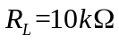
3.Diode

4.signal generator

2.1.2 Experimental steps
1.Connect the circuit according to the figure 1
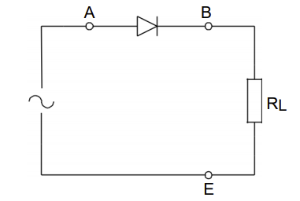
Figure 1：Rectifier Circuit [2]

2.Input signal 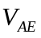= 10 and 2 volt (peak-to-peak amplitude)
3.Set the frequency of the signal generator to 10 kHz
4.Adjust the Oscilloscope
5.Measure the voltage at both ends of 、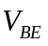
6.Record the image

2.1.3 Experimental results
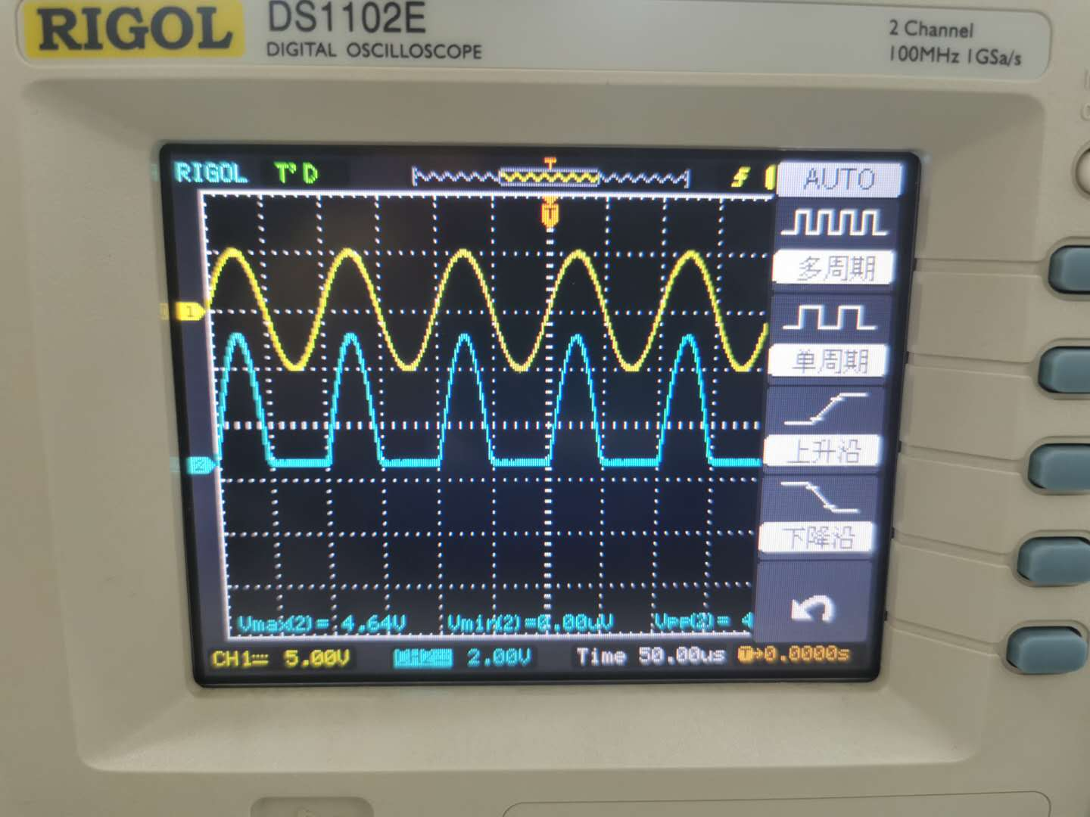
Figure 2：Images of and when 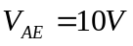

In the image, we can find that the shape of input signal is a sine function and the maximum and minimum values of are 5V and -5V, respectively. is the voltage at both ends of the diode which is only a part of , the signal of is rectified. The maximum and minimum values of are 4.64V and 0V respectively. 4.64V is due to the presence of 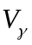 in the diode and 0V is due to the current being cut off when it passes through the diode in reverse.

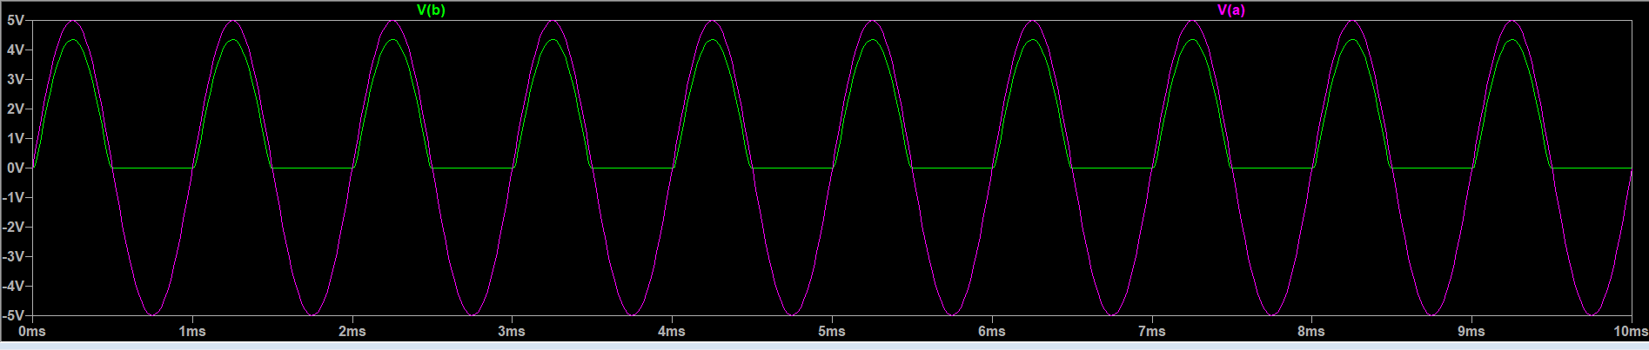
Figure 3：The simulation results

In order to verify the experimental results more accurately and intuitively, we carried out simulation.The purple line represents , and the green line represents . By comparison, we find that the simulation results are very close to the experimental results.

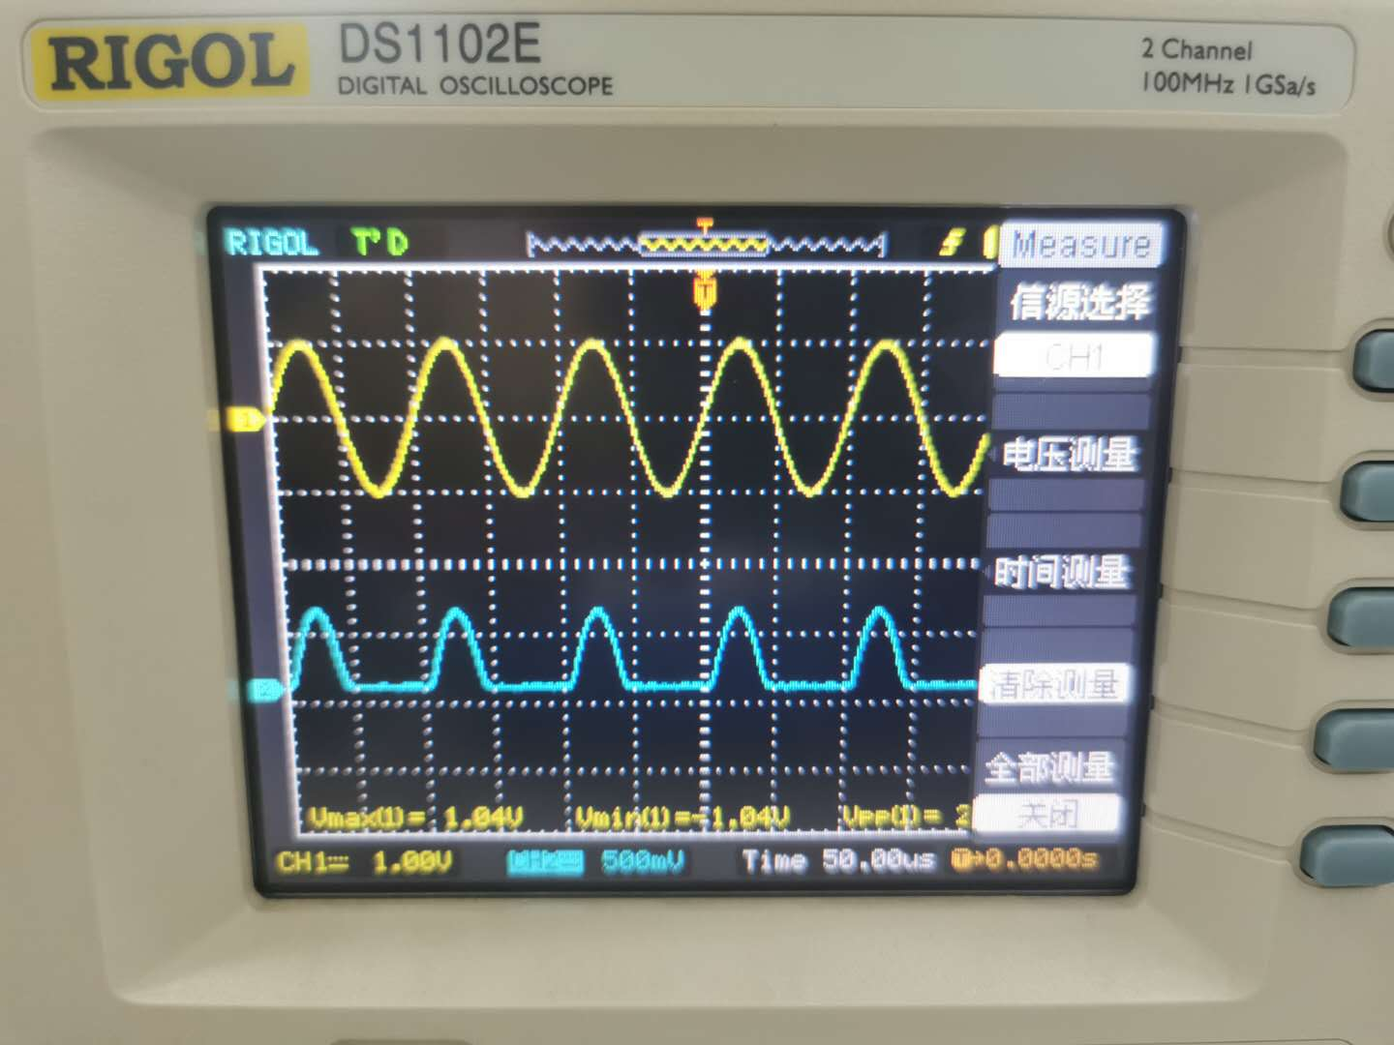
Figure 4：Images of and when 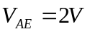

The circuit is the same as the previous experiment where = 10V which is also a half-wave rectifier circuit with the maximum and minimum values of are 1.04V and -1.04V respectively. The shape of input signal is a sine function.Because the input signal is 2V less than 10V, the whole image shrinks.The maximum and minimum values of are 0.58V and 0V, respectively. 0.58V is due to the presence of in the diode. The 0V is due to the diode being cut off by a single guide when the current in the circuit is reversed.

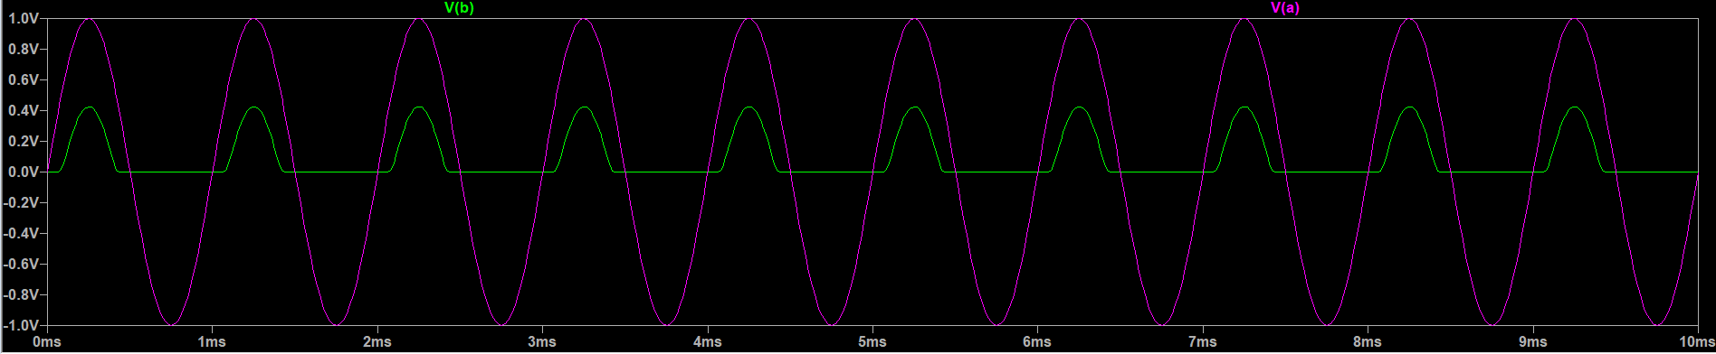
Figure 5：The simulation results

In order to verify the experimental results more accurately and intuitively, we carried out simulation.The purple line represents , and the green line represents . By comparison, we find that the simulation results are very close to the experimental results.

2.1.4 Brief summary

Through the experiment of the half-wave rectifier circuit, we found that when the current in the circuit is reversed, due to the single guiding property of the diode, there is basically no current flowing in the circuit. If using half wave rectifier output voltage, the disadvantage is that "waste" negative half cycle which can not be used to all available energy. In addition, if the input voltage is reduced, the voltage at the diode will also be reduced.In experiment 2, 0.58V is due to the presence of in the diode. Although the experimental data have some error,the error is within the negligible range that means the experiment is successful

2.2 Smoothed rectifier
2.2.1Experiment equipment
1.Oscilloscope
2. resistor and 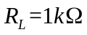
3.Diodes ：1N4148

4.Capacitor：C = 100nF

5.Function generator

2.2.2 Experimental steps
1.Connect the circuit according to the figure 6
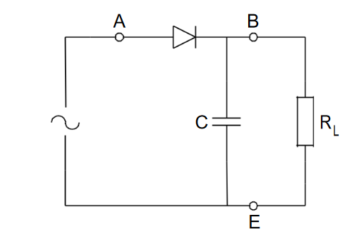
Figure 6 ：Smoothed rectifier[2]

2.Input signal = 10 volt (peak-to-peak amplitude)
3.Use two resistor of 10KΩ、1KΩ as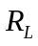
4.Set the frequency of the Function generator to 10 kHz
5.Adjust the Oscilloscope
6..Measure the voltage and
7.Record the images

2.2.3 Experimental results

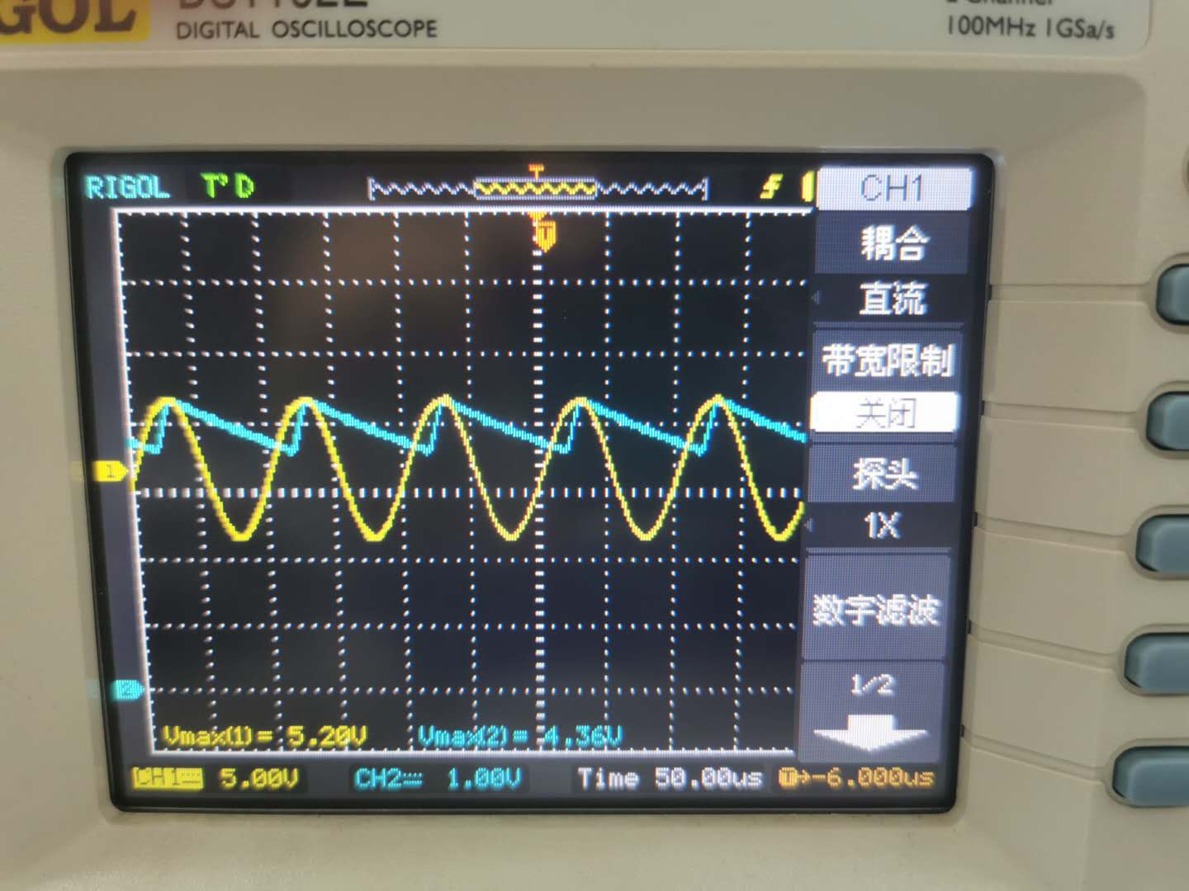
Figure 7：Images of and when 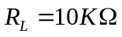

As we can see from the image,the shape of input signal is a sine function.The maximum and minimum values are 5.20v and -5.00v, respectively.The shape of is "ripple" . The maximum and minimum values are 4.36v and 3.52v respectively. When the input signal reaches the peak value, the capacitor is also charged to its maximum voltage. As the output voltage decreases, the diode becomes reverse biased and the capacitor discharges through the output resistor. At the same time, we notice that the difference between the peak time of the input voltage and the cut-off time of the diode is very short, which may be due to the high resistance value.

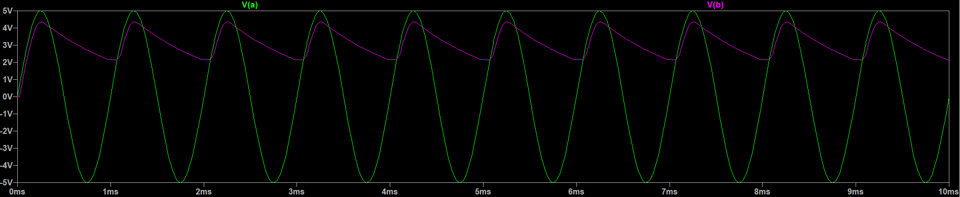
Figure 8：The simulation results

In order to verify the experimental results more accurately and intuitively, we carried out simulation.The green line represents , and the purple line represents . By comparison, we find that the simulation results are very close to the experimental results.

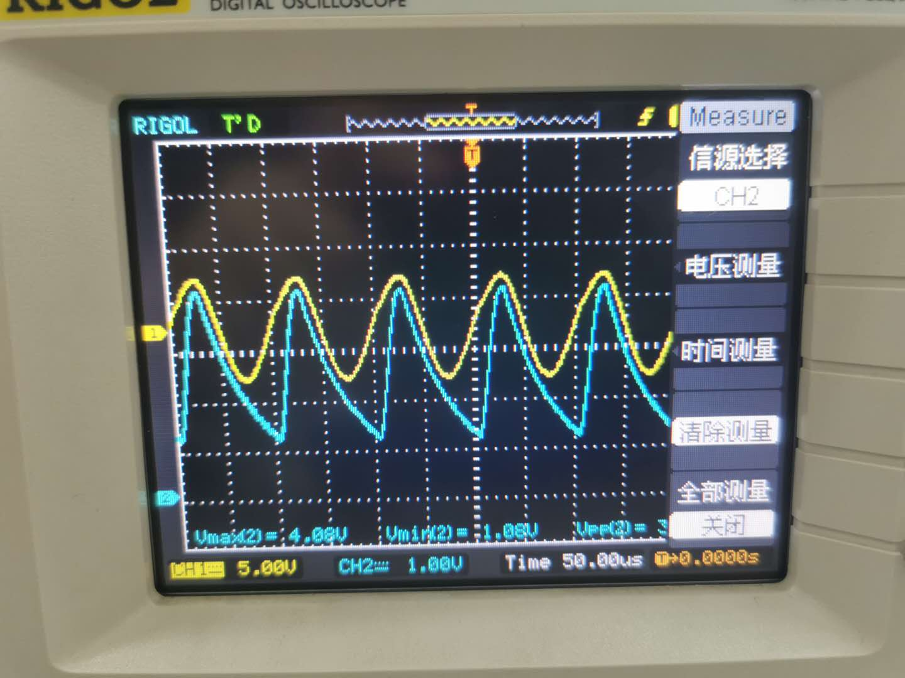
Figure 9：Images of and when 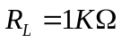
From the image, we can see that is a sine function and the maximum and minimum values of are 5.00V and -5.00v respectively. The shape of is also "ripple" .the maximum and minimum values of are 4.08v and 1.08v respectively. The reason is the same as the above experiment. In addition, due to the change to 1K Ω, the difference between the maximum and minimum voltage between be becomes larger and volatility becomes more apparent., which indicate that the rate of discharge will depend on the value of .

The voltage at both ends of the resistor can be written as:

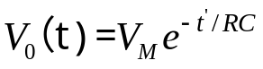

Where,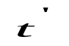is the time after the output voltage reaches the peak value, and RC is the time constant of the circuit.Different resistance values lead to different voltages. The conclusion of the above two experiments can also be explained.

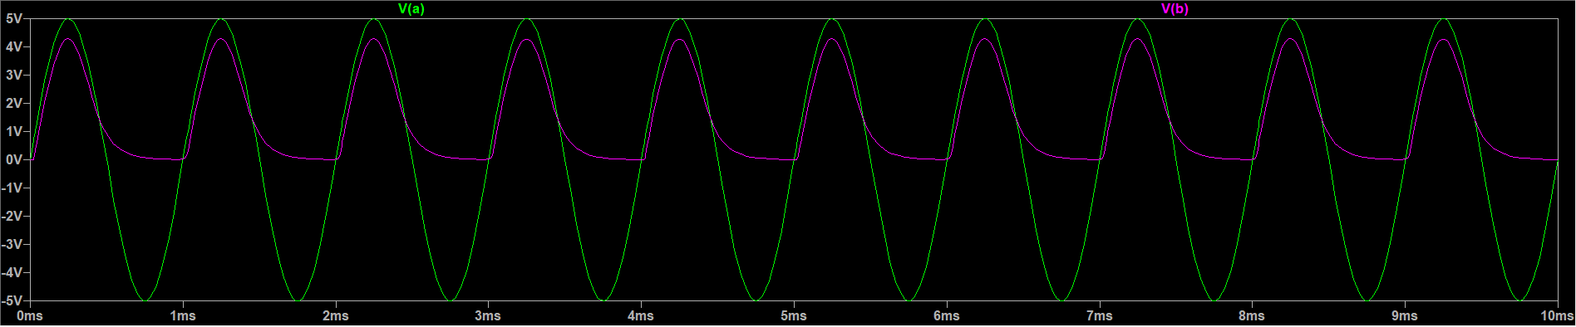
Figure 10：The simulation results

In order to verify the experimental results more accurately and intuitively, we carried out simulation.The green line represents , and the purple line represents . By comparison, we find that the simulation results are very close to the experimental results.

2.2.4 Brief summary

It is found that if a capacitor is connected in parallel to the resistance of a half wave rectifier circuit, forming a simple Smoothed rectifier circuit, and the capacitor filters out a large proportion of the sinusoidal signal, the sinusoidal half-wave voltage can be converted into a DC voltage. The image of the output voltage is related to the value of the load resistance. The larger the resistance, the smaller the difference between the maximum and minimum values. At the same time, according to the comparison between the first and second experimental images, we find that when the load resistance (RC time constant) is very large, the cut-off time of the input voltage and the diode will differ for a period of time.

2.3Limiter/Clipper
2.3.1 Experiment equipment
1.Oscilloscope

2.resistor 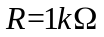

3.Diodes ：1N4148

4.Function generator

5.DC Power Supply

2.3.2 Experimental steps
1.Connect the circuit according to the figure 11
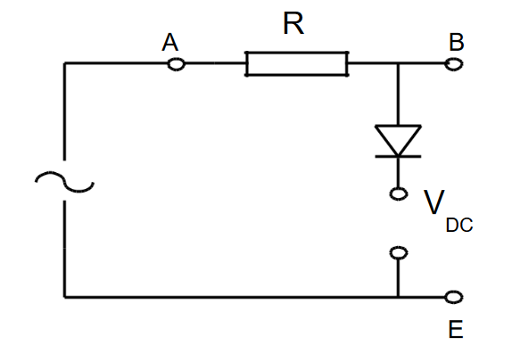
Figure 11：Voltage Limiter Circuit[2]

2.Input signal = 10 volt (peak-to-peak amplitude)
3.Use a resistor of 1K Ω as
4.Set the frequency of the signal generator to 10 kHz
5.Adjust the Oscilloscope
Experiment 1： Set 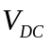= 0 volt
Experiment2：Set = +3 volt
Experiment3：Set = +3 volt with the diode connection reversed
6.Measure the voltage and
7.Record the images

2.3.3 Experimental results

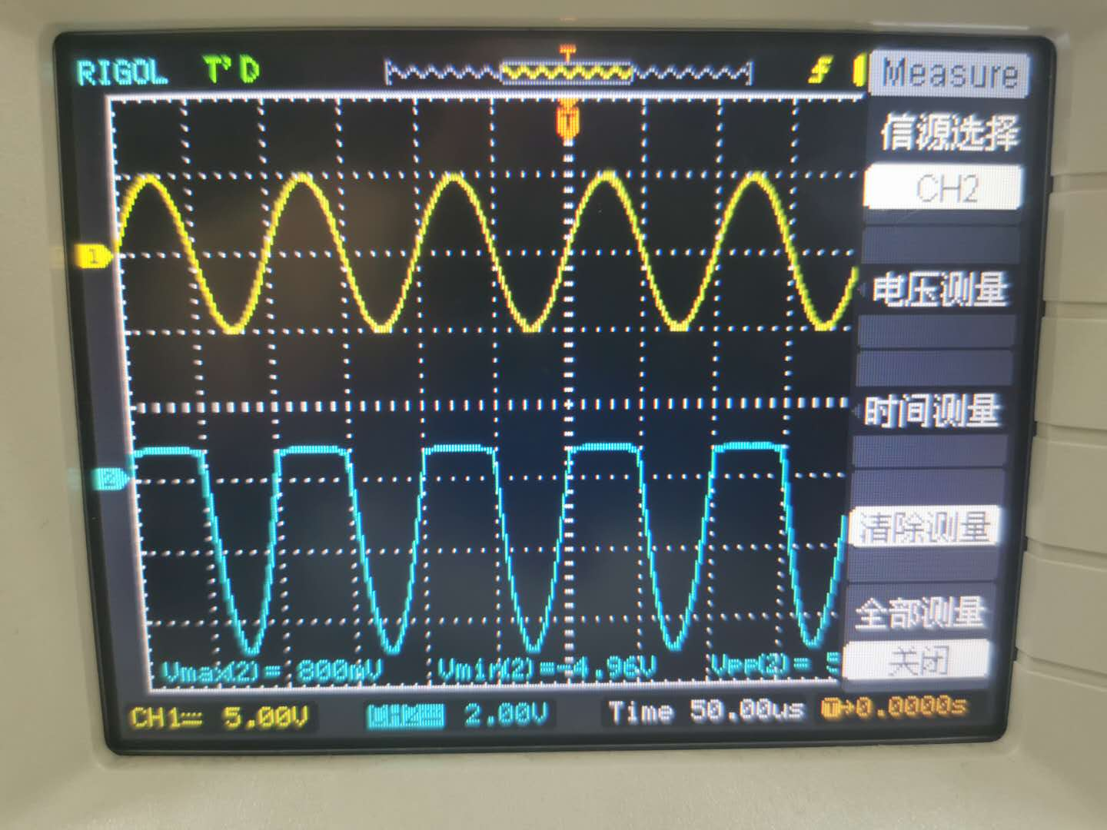
Figure 12:Images of and when = 0

As you can see from the graph, is a sine function.The maximum and minimum values of are 5.00V and -5.00 respectively. is a sine function without upper part.The maximum and minimum values of were 0.8V and -4.96V, respectively.Since = 0 Volt, there is no DC voltage.The Voltage Limiter Circuit becomes a circuit in which resistors are connected in series with diodes. This diode allows current through it when The anode potential is approx. 0.7V higher than The anode potential. Because of the presence of,our experimental data is 0.8V which is within the allowable range of error. When the current is reversed,measures the power supply voltage.So the minimum value of is -4.96V.

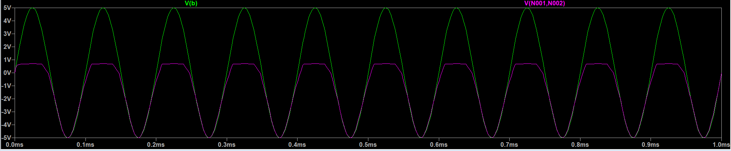
Figure 13：The simulation results

In order to verify the experimental results more accurately and intuitively, we carried out simulation.The green line represents , and the purple line represents . By comparison, we find that the simulation results are very close to the experimental results.

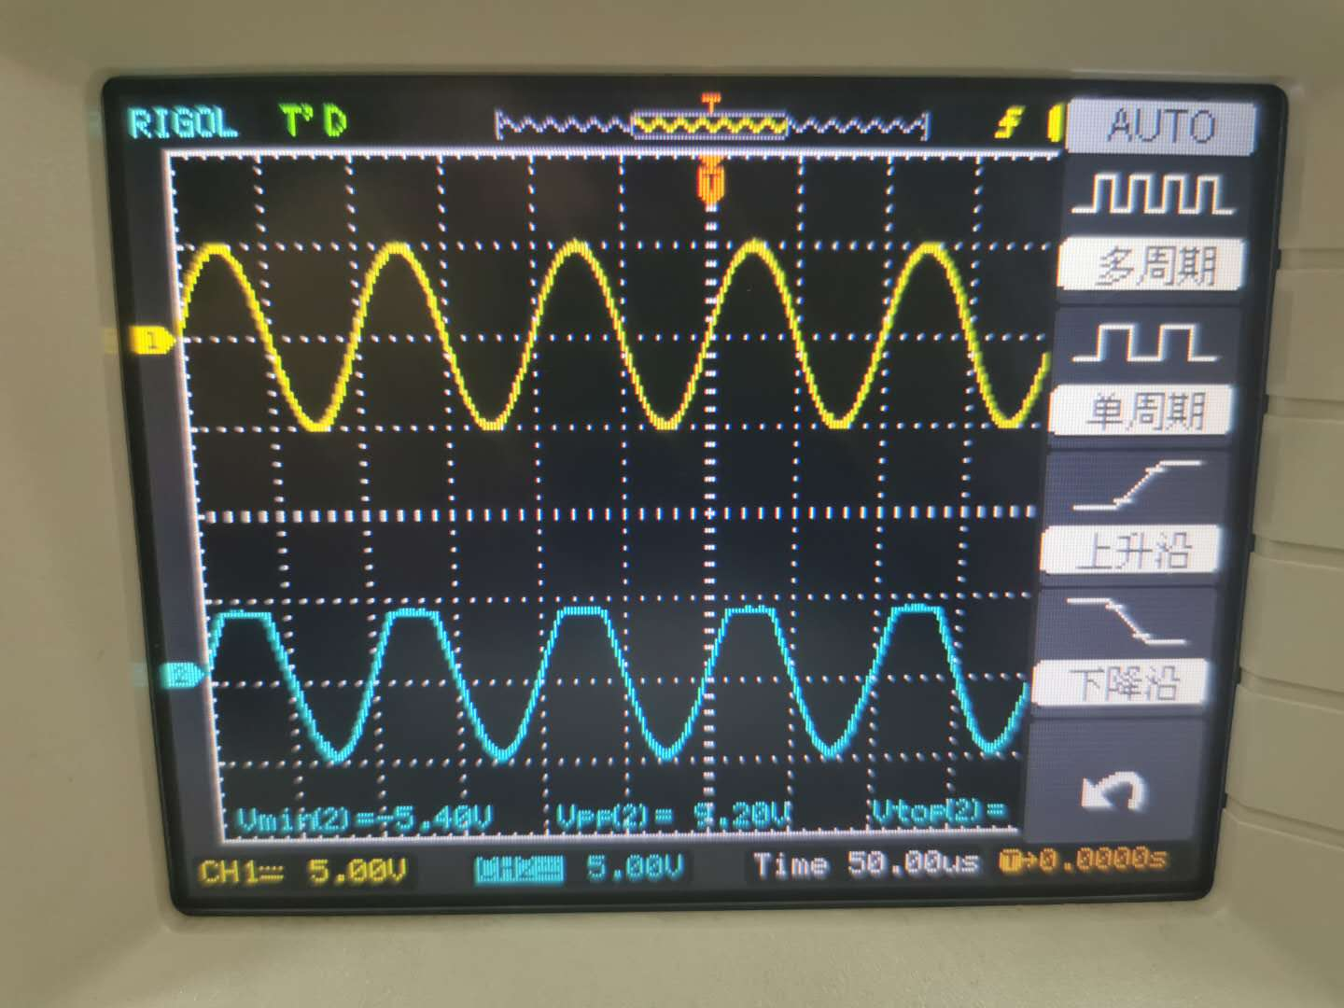
Figure 14:Images of and when = 3 volt

As can be seen from the image, is also a sine function.The maximum and minimum values of are 5.00V and -5.00V respectively. is a sine function without the upper part and the maximum and minimum values of are 3.76V and -5.40V respectively. Since = 3 Volt, the measured value is the diode voltage plus when the current is going through. Since the diode voltage is about 0.7V, the output voltage is 3.76V. When the current is reversed with the cut-off of diode, the value of is the value of the supply voltage, so the minimum value is about -5.40V.

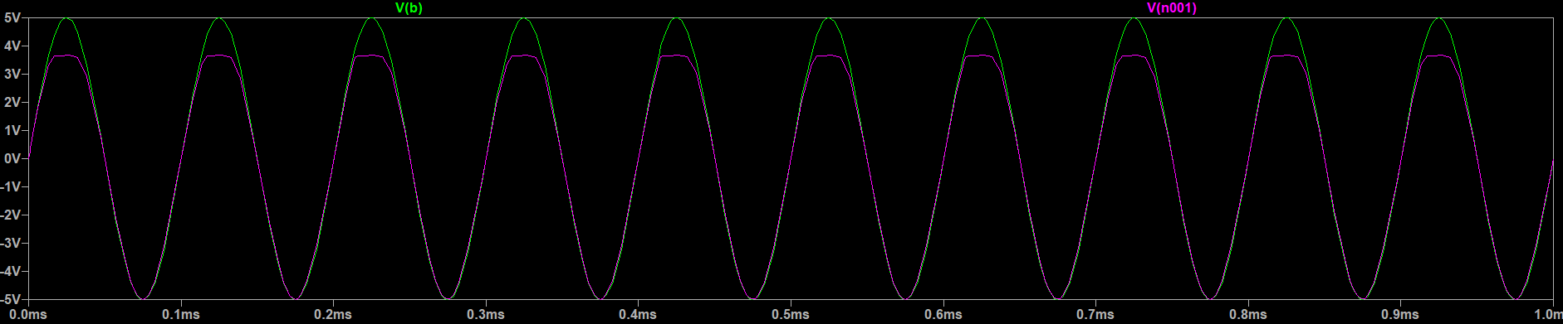
Figure 15：The simulation results

In order to verify the experimental results more accurately and intuitively, we carried out simulation.The green line represents , and the purple line represents . By comparison, we find that the simulation results are very close to the experimental results.

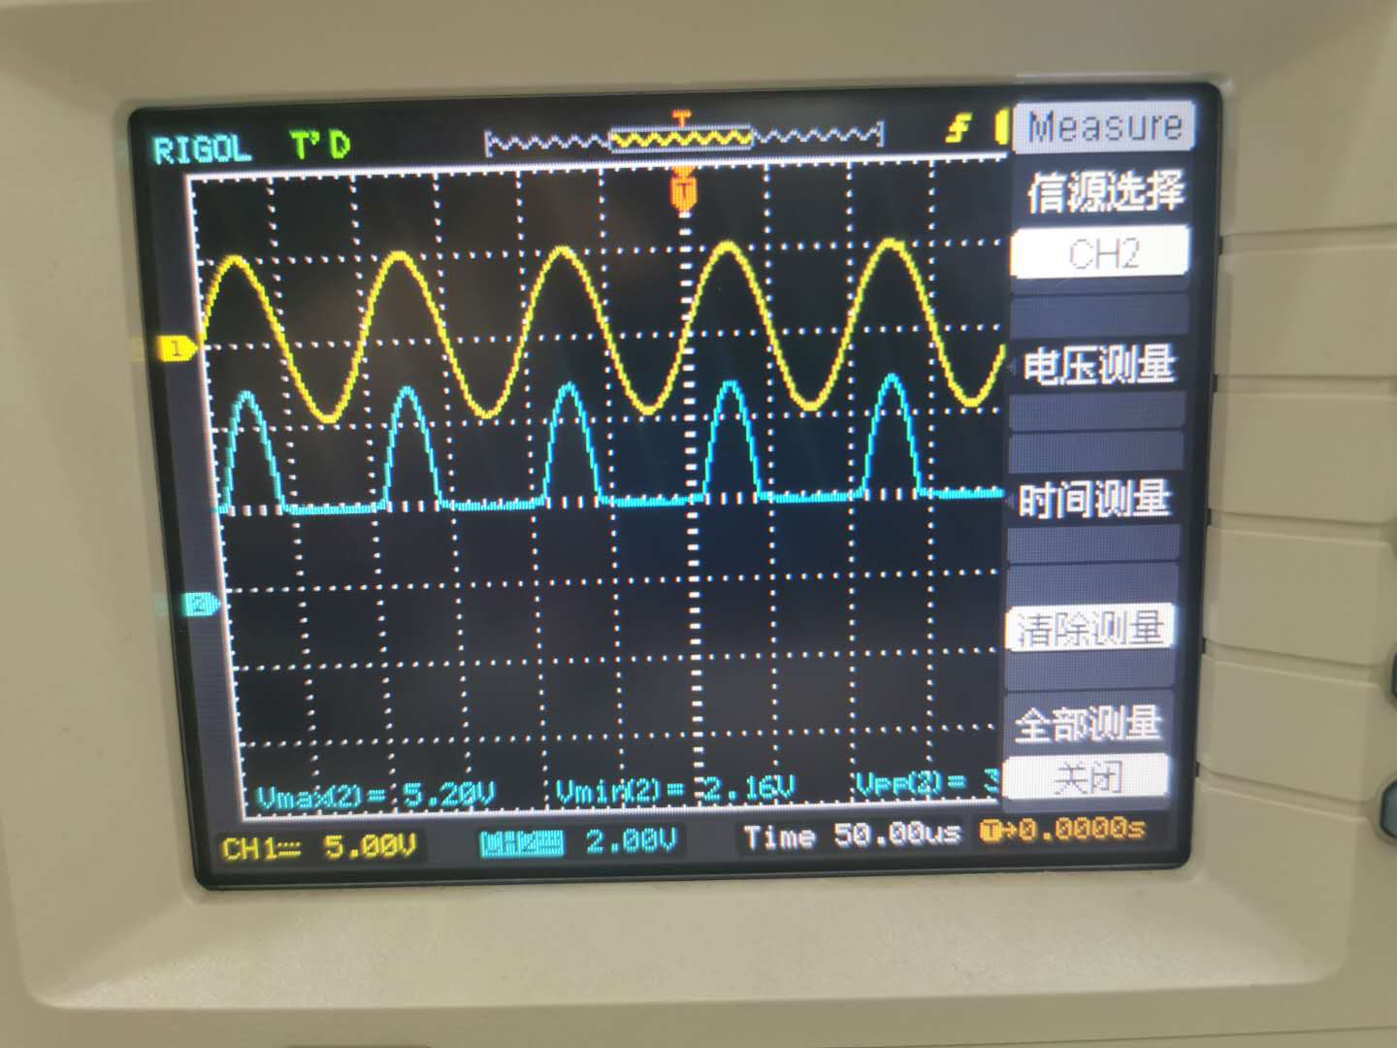
Figure 16：Images of and when the diode is reversed、= 3 volt

It can be seen from the image that is also a sine function. The maximum and minimum values of are 5.00V and -5.00V respectively. is a sine function without the lower part. The maximum and minimum values of is a sine function without the lower part are 5.20V and 2.16V respectively. As the diode is reversed, the output voltage is 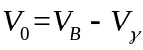, so the minimum output voltage is about 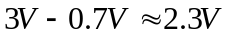. 2.16V is not far from 2.3V and the error is within the allowable range. The maximum value is about the maximum supply voltage which is about 5V.

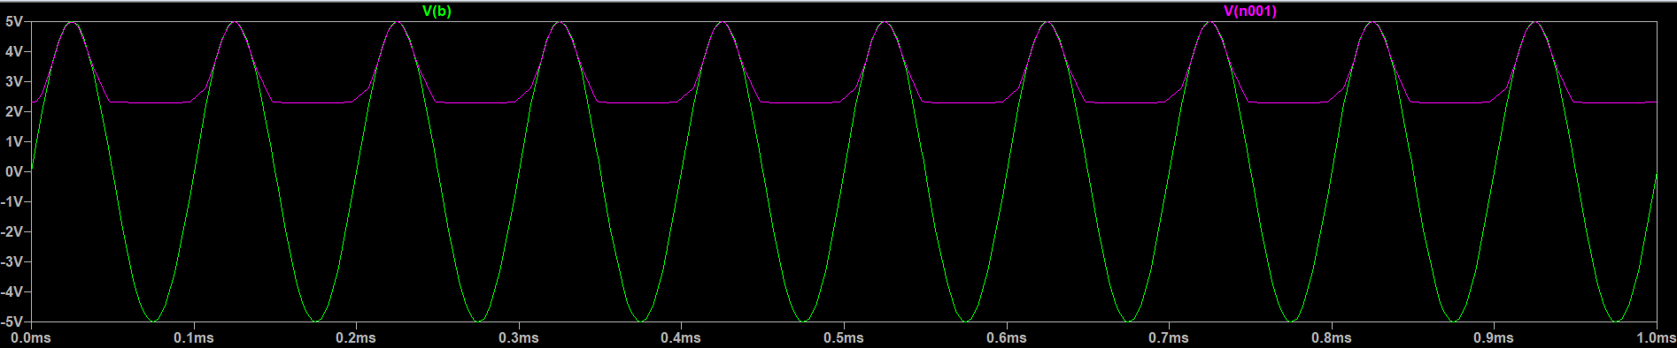
Figure 17：The simulation results

In order to verify the experimental results more accurately and intuitively, we carried out simulation.The green line represents , and the purple line represents . By comparison, we find that the simulation results are very close to the experimental results.

2.3.4 Brief summary

According to the three experiments, we can summarize the rule of the limiter circuit. In experiment 2, the output voltage 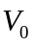is limited to 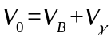 when the diode is on. In experiment 3, the minimum output voltage is limited to 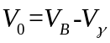. Therefore, the limiter circuit can effectively limit the portion of the signal above or below a given level.

2.4 Voltage Clamper
2.4.1 Experiment equipment

1.Oscilloscope

2.Capacitor C=10nF

3.Diodes ：1N4148

4.signal generator

2.4.2 Experimental steps

1.Connect the circuit according to the figure 18
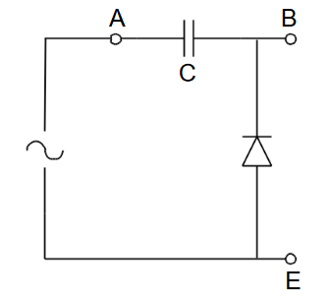
Figure 18 ：Voltage Clamper[2]

2.Set the frequency of the signal generator to 10 kHz
3.Adjust the Oscilloscope
Experiment 1：Set = 10 volt (peak-to-peak amplitude)
Experiment 2：When the diode is reverse biased，set = 10 volt (peak-to-peak amplitude)
4.Measure the voltage and 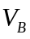
5.Record the images

2.4.3 Experimental results

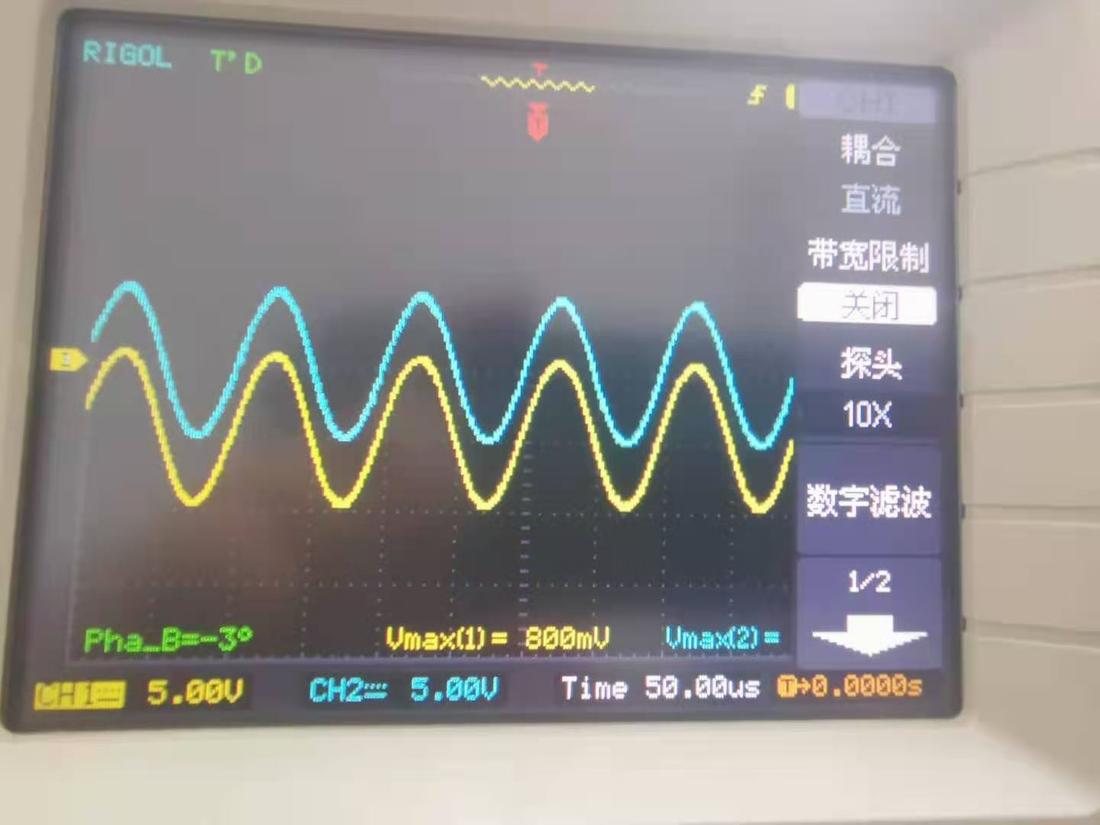
Figure 19：Images of and when = 10 volt

From the graph, we can see that both curves are sine functions. The maximum and minimum values of are 4.6V and -5.4V respectively. The maximum and minimum values of are 9V and -1.00V respectively. The shape and size of the curves are identical, indicating that the clamp circuit merely shifts the entire signal voltage by a DC level. Due to the single wizard of the diode, the output voltage:
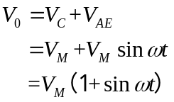
So the image of 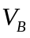 is going to be shifted up by one 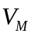, which is about 5V, and in the experiment, The difference between the maximum value of 9.00V and the maximum value of 4.60V of is 4.4V. 4.4 is not different from 5V which is within the allowable range of error.

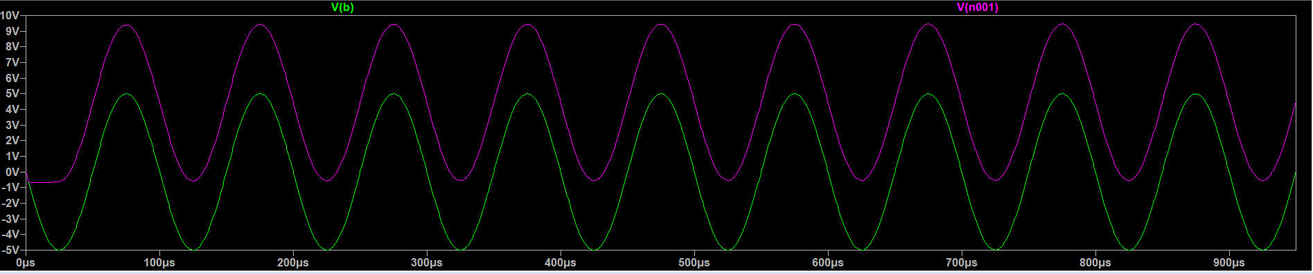
Figure 20：The simulation results

In order to verify the experimental results more accurately and intuitively, we carried out simulation.The green line represents , and the purple line represents . By comparison, we find that the simulation results are very close to the experimental results.

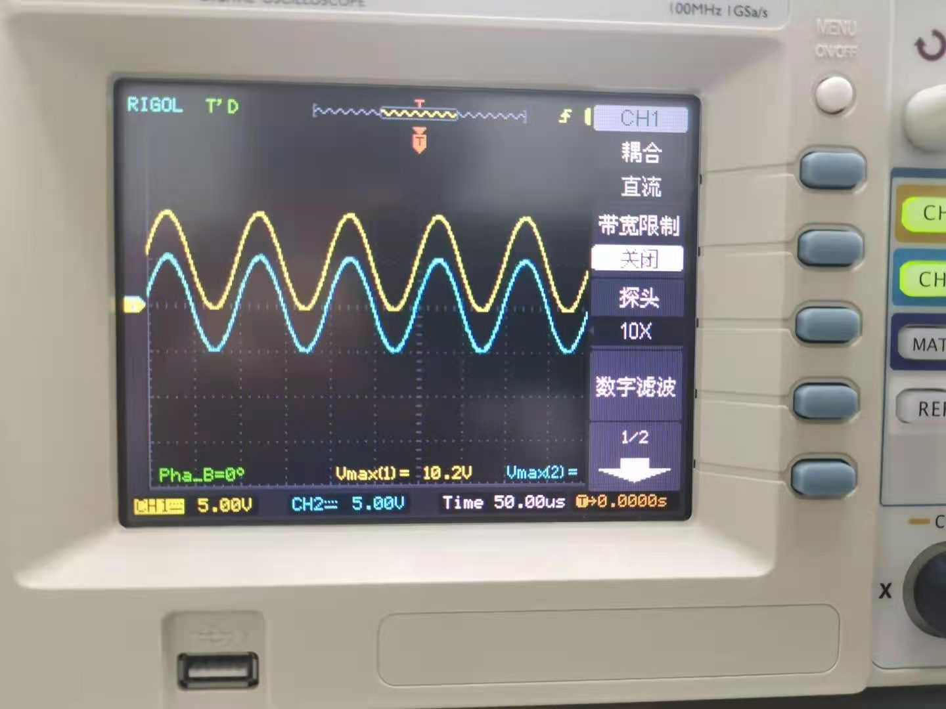
Figure 21：Images of and when the diode is reversed、= 10 volts

From the figure, we can see that both curves are sine functions. The maximum and minimum values of were 4.8V and -5.2V, respectively; the maximum and minimum values of were 0.6V and -9.2V, respectively. We assume that the capacitor is initially uncharged. In the first quarter cycle of the input waveform, the voltage at both ends of the capacitor follows the signal. After reaching the peak value, the diode begins to reverse bias. Since the ideal capacitor cannot discharge, the voltage at both ends of the capacitor remains at 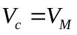.
According to Kirchhoff's voltage law:
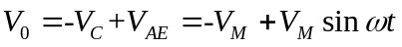
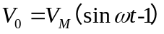
So the image of is going to be shifted down by one , which is about 5V.In the experiment, the difference between the maximum value of 4.80V and the maximum value of 0.6V of is 4.2V. 4.2 is not different from 5V which is within the allowable range of error.

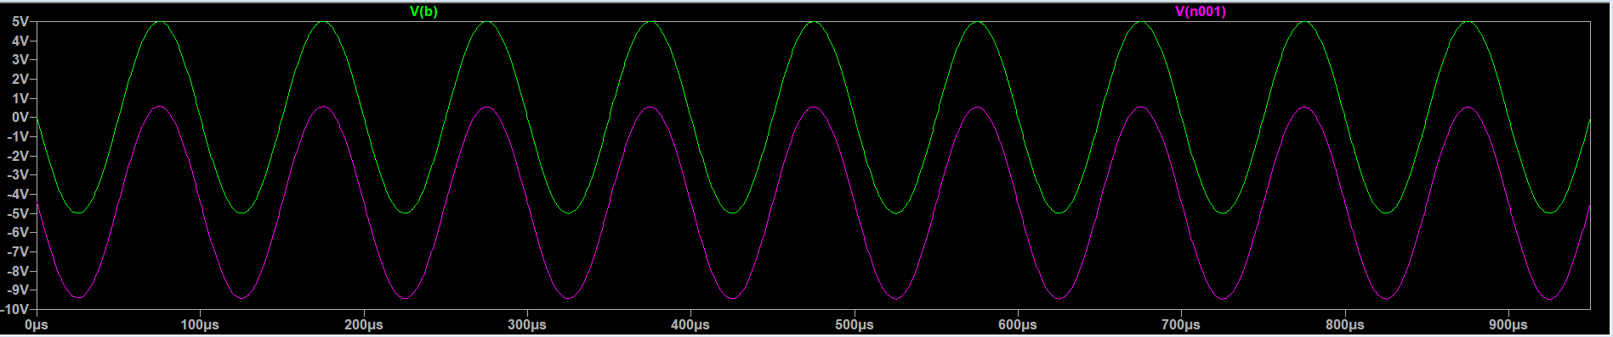
Figure 22：The simulation results

In order to verify the experimental results more accurately and intuitively, we carried out simulation.The green line represents , and the purple line represents . By comparison, we find that the simulation results are very close to the experimental results.

2.4.4 Brief summary

According to the experimental images, we find that the shape and size of the curve are exactly the same, which indicates that the function of the clamp is to translate the entire signal voltage to a DC level. In experiment 1, the output signal is shifted up by a level signal; in Experiment 2, the output signal is shifted down by a level signal. At the same time, we also verified the conclusion through the formula. Through experiments, we can also show that clamping circuit adjustment dc usually do not need to know the exact waveform.
2.5 Diode logic
2.5.1 Experiment equipment
1.Oscilloscope

2. resistor 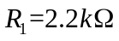 and

3.Diodes ：1N4148

4.DC Power Supply

2.5.2 Experimental steps

1.Connect the circuit according to the figure 23
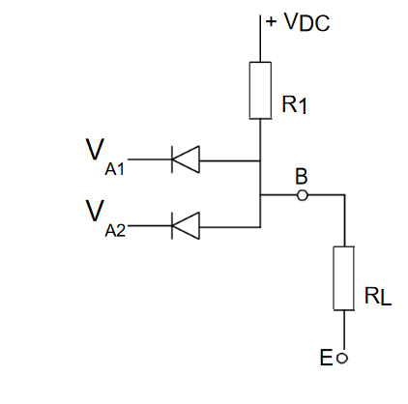
Figure 23. Diode Logic Gate Circuit[2]

2.Open Digital Multimeter
Experiment 1:Set 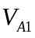=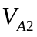= +5 volt
Experiment 2:Set = 0 volt,= +5 volt
Experiment 3:Set= 5 volt,= 0 volt
Experiment 4: Set == 0 volt
3.Measure the DC output voltage
4.Record the data

2.5.3 Experimental results

Table of and and
5 | 5 | 4.2
0 | 5 | 0.644
5 | 0 | 0.642
0 | 0 | 0.611

Due to , when == +5 Volt,the output voltage would be less than 5, and in experiments 2, 3, and 4, the voltage would be greater than 0.

Truth table
1 | 1 | 1
0 | 1 | 0
1 | 0 | 0
0 | 0 | 0

Logic 0: voltage near zero
Logic 1: voltage close to the supply voltage
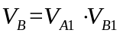
According to the table, it conforms to Output=A∙B, so this circuit is AND Logic Circuit

2.5.4 Brief summary

Through experiments, we explored the logic circuit of the diode and the four operating conditions of the circuit determined by various combinations of input voltages. Also, "Truth Table" is drawn through actual measurement to verify that this circuit is AND Logic Circuit.

2.6 Zener Stabiliser
2.6.1 Experiment equipment
1.Oscilloscope

2.Zener Diodes

3.DC Power Supply

4. Resistor ：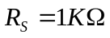，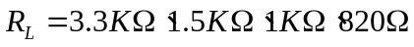
2.6.2 Experimental steps

1.Connect the circuit according to the figure 24
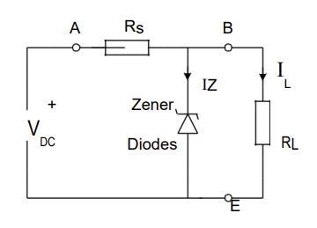
Figure 24：Zener Stabiliser Circuit[2]

Experiment 1：Vary from 0 volt to 20 volts in 2-volt steps and measure and without .
Experiment 2：Set = 20 volts with 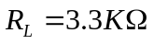
Experiment3：Set = 20 volts with 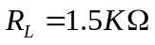
Experiment4：Set = 20 volts with
2.Measure the data
3.Record the data

2.6.3 Experimental results

The table of and
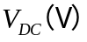 | 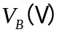
0 | 0
2 | 2.04
4 | 4.06
6 | 6.03
8 | 8.01
10 | 9.93
12 | 9.97
14 | 10.01
16 | 10.04
18 | 10.08
20 | 10.11

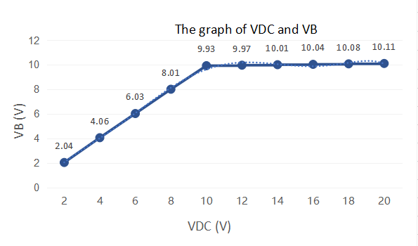
Figure 25：The graph of and

Through the table and line graph, we find that when 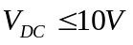 , increases linearly with the increase of . When , basically remains unchanged with the increase of , playing a role in stabilizing the output. The e reason for this is that the Zener diode was not broken down before 10 Volts, resulting in the current being blocked. The value measured is the supply voltage. Because the experiment is using 10 volt Zener diode which is working in breakdown area after 10 volts.Zener diode breakdown voltage in a wide range of reverse bias current is almost constant, within a certain range of diode breakdown voltage will be basic remain unchanged, so it would appear after 10 volts that with the increase of , remains unchanged.If the Zener resistance of the diode is 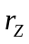: the change in output voltage is only a fraction 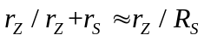 of the change in the input voltage.

The table of and and 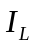

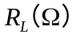 |  | 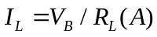
3300 | 10.23 | 0.0031
1500 | 10.08 | 0.0067
1000 | 9.93 | 0.0099
680 | 8.91 | 0.0131

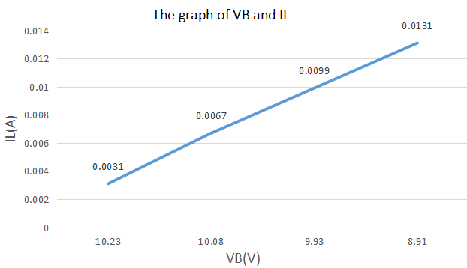
Figure 26：The graph of and

2.6.4 Brief summary

Based on the above experiments, we found that since the breakdown voltage of the Zener diode is almost constant over a wide reverse bias current range.Therefore, the Zener diode regulator circuit can be used as a constant voltage reference circuit. Even if the input voltage changes a lot, the output voltage will not change much, but will remain basically constant.

2.7 Light-emitting diodes
2.7.1 Experiment equipment

1.Oscilloscope

2. resistor 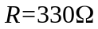

3.LED

4.signal generator

2.7.2 Experimental steps

- Connect the circuit according to the figure 14

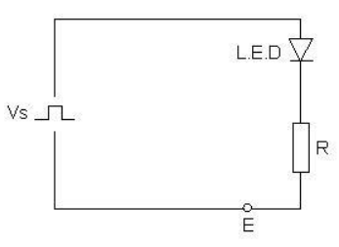
Figure 27：Optical Receiver[2]

2.Set 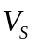 = 10 V p-p square-wave from signal generator
3.Input signal = 10 V p-p square-wave

4.Set the frequency of the signal generator to 2Hz

5.check that the LED is flashing ：When the LED conducts electricity, use an oscilloscope to measure the voltage drop on the LED
6.Use the Oscilloscope to observe the waveform of the voltage drop across the LED

2.7.3 Experimental results
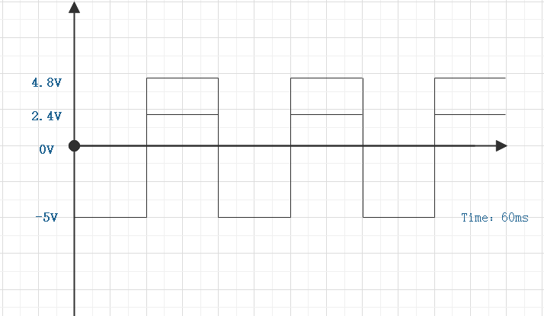
Figure 28:The experimental results

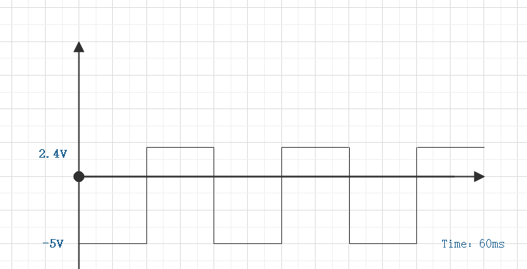
Figure 29:The waveform of the voltage drop across the LED

Light-emitting diodes convert current into light signals.Therefore, the current flowing through the LED will reduce the voltage flowing through the LED. When the current flows back into the LED, the current cannot pass through the LED due to Unidirectional conduction of LED , so the voltage is reduced by 5V.

2.7.4 Brief summary

When the diode is forward biased, the electrons and holes will pass through the space charge area and become excess minority carriers. Minority carriers diffuse to the neutral N and P regions and compound with the majority of carriers there. When the compound occurs, the emission of photons will be caused, resulting in the voltage decrease. When the current reverse flow into the LED, the current cannot pass through the LED due to the Unidirectional conduction of LED. So there will also be LED lights flashing.

3 Conclusion

In the rectifier circuit,
When the current in the circuit is reversed, due to the single guiding property of the diode, there is basically no current flowing in the circuit. In addition, if the input voltage is reduced, the voltage at the diode will also be reduced as well.

In the Smoothed rectifier circuit
By filtering out a large part of the sinusoidal signal, a capacitor can change the sinusoidal half-wave voltage into a DC voltage.The larger the resistance, the smaller the difference between the maximum and minimum values. At the same time, we find that when the load resistance (RC time constant) is very large, the cut-off time of the input voltage and the diode will differ for a period of time.

In the Limiter/Clipper circuit
Based on three experiments, we found that the limiter circuit can effectively limit the part of the signal above or below a certain level.

In the Voltage Clamper circuit
According to the experimental images, we found that the function of the clamp is to shift the entire signal voltage to a DC level by the circuit, and we also verified this conclusion by the formula. Through experiments, we also found that clamping circuit adjustment DC usually do not need to know the exact waveform.

In the Diode logic circuit
Through experiments, we explored the logic circuit of the diode, the four operating conditions of the circuit determined by various combinations of input voltages. Master the method of judging diode logic circuit.

In the Zener Stabiliser circuit
Based on the experiments, we found that since the breakdown voltage of the Zener diode is almost constant over a wide reverse bias current range, the Zener diode regulator circuit can be used as a constant voltage reference circuit. Even if the input voltage changes a lot, the output voltage will not change much, but will remain basically constant.

In the Light-emitting diodes circuit
When the diode is forward biased, the electrons and holes will pass through the space charge area and become excess minority carriers. Minority carriers diffuse to the neutral N and P regions and compound with the majority of carriers there. When the compound occurs, the emission of photons will be caused, resulting in the voltage decrease. When the current reverse flow into the LED, the current cannot pass through the LED due to the Unidirectional conduction of LED. So there will also be LED lights flashing.

4.Reference list:
[1] Fluke,“What is a diode?.[Online]. Available:https://www.fluke.com/en us/learn/blog/electrical/what-is-a-diode
[2]Department of Electrical and Electronic Engineering, “Diodes Characteristics and Their Applications”.[Online]. Available:file:https://learningmall.xjtlu.edu.cn/mod/folder/view.php?id=40355

